### Semester Two Examination, 2023

### Question/Answer booklet

# 12 SPECIALIST MATHEMATICS

**UNIT 3**

## Section Two:

## Calculator-assumed

Your Name _______________________________

Your Teacher’s Name _________________________

## Time allowed for this section

Reading time before commencing work: ten minutes

Working time: one hundred minutes

## Materials required/recommended for this section

***To be provided by the supervisor***

This Question/Answer booklet

Formula sheet (retained from Section One)

***To be provided by the candidate***

Standard items: pens (blue/black preferred), pencils (including coloured), sharpener, correction fluid/tape, eraser, ruler, highlighters

Special items: drawing instruments, templates, notes on two unfolded sheets of A4 paper, and up to three calculators approved for use in this examination

## Important note to candidates

No other items may be taken into the examination room. It is **your** responsibility to ensure that you do not have any unauthorised material. If you have any unauthorised material with you, hand it to the supervisor **before** reading any further.

|  |  |  |  |  |  |
| --- | --- | --- | --- | --- | --- |
| **Question** | **Marks** | **Max** | **Question** | **Marks** | **Max** |
| **7** |  | **4** | **16** |  | **7** |
| **8** |  | **10** | **17** |  | **6** |
| **9** |  | **11** | **18** |  | **8** |
| **10** |  | **5** | **19** |  | **9** |
| **11** |  | **5** |
| **12** |  | **13** |
| **13** |  | **6** |
| **14** |  | **6** |
| **15** |  | **7** |

**Structure of this paper**

|  |  |  |  |  |  |
| --- | --- | --- | --- | --- | --- |
| Section | Number of questions available | Number of questions to be answered | Working time (minutes) | Marks available | Percentage of examination |
| Section One:  Calculator-free | 6 | 6 | 50 | 50 | 34 |
| Section Two:  Calculator-assumed | 13 | 13 | 100 | 97 | 66 |
|  |  |  |  | **Total** | 100 |

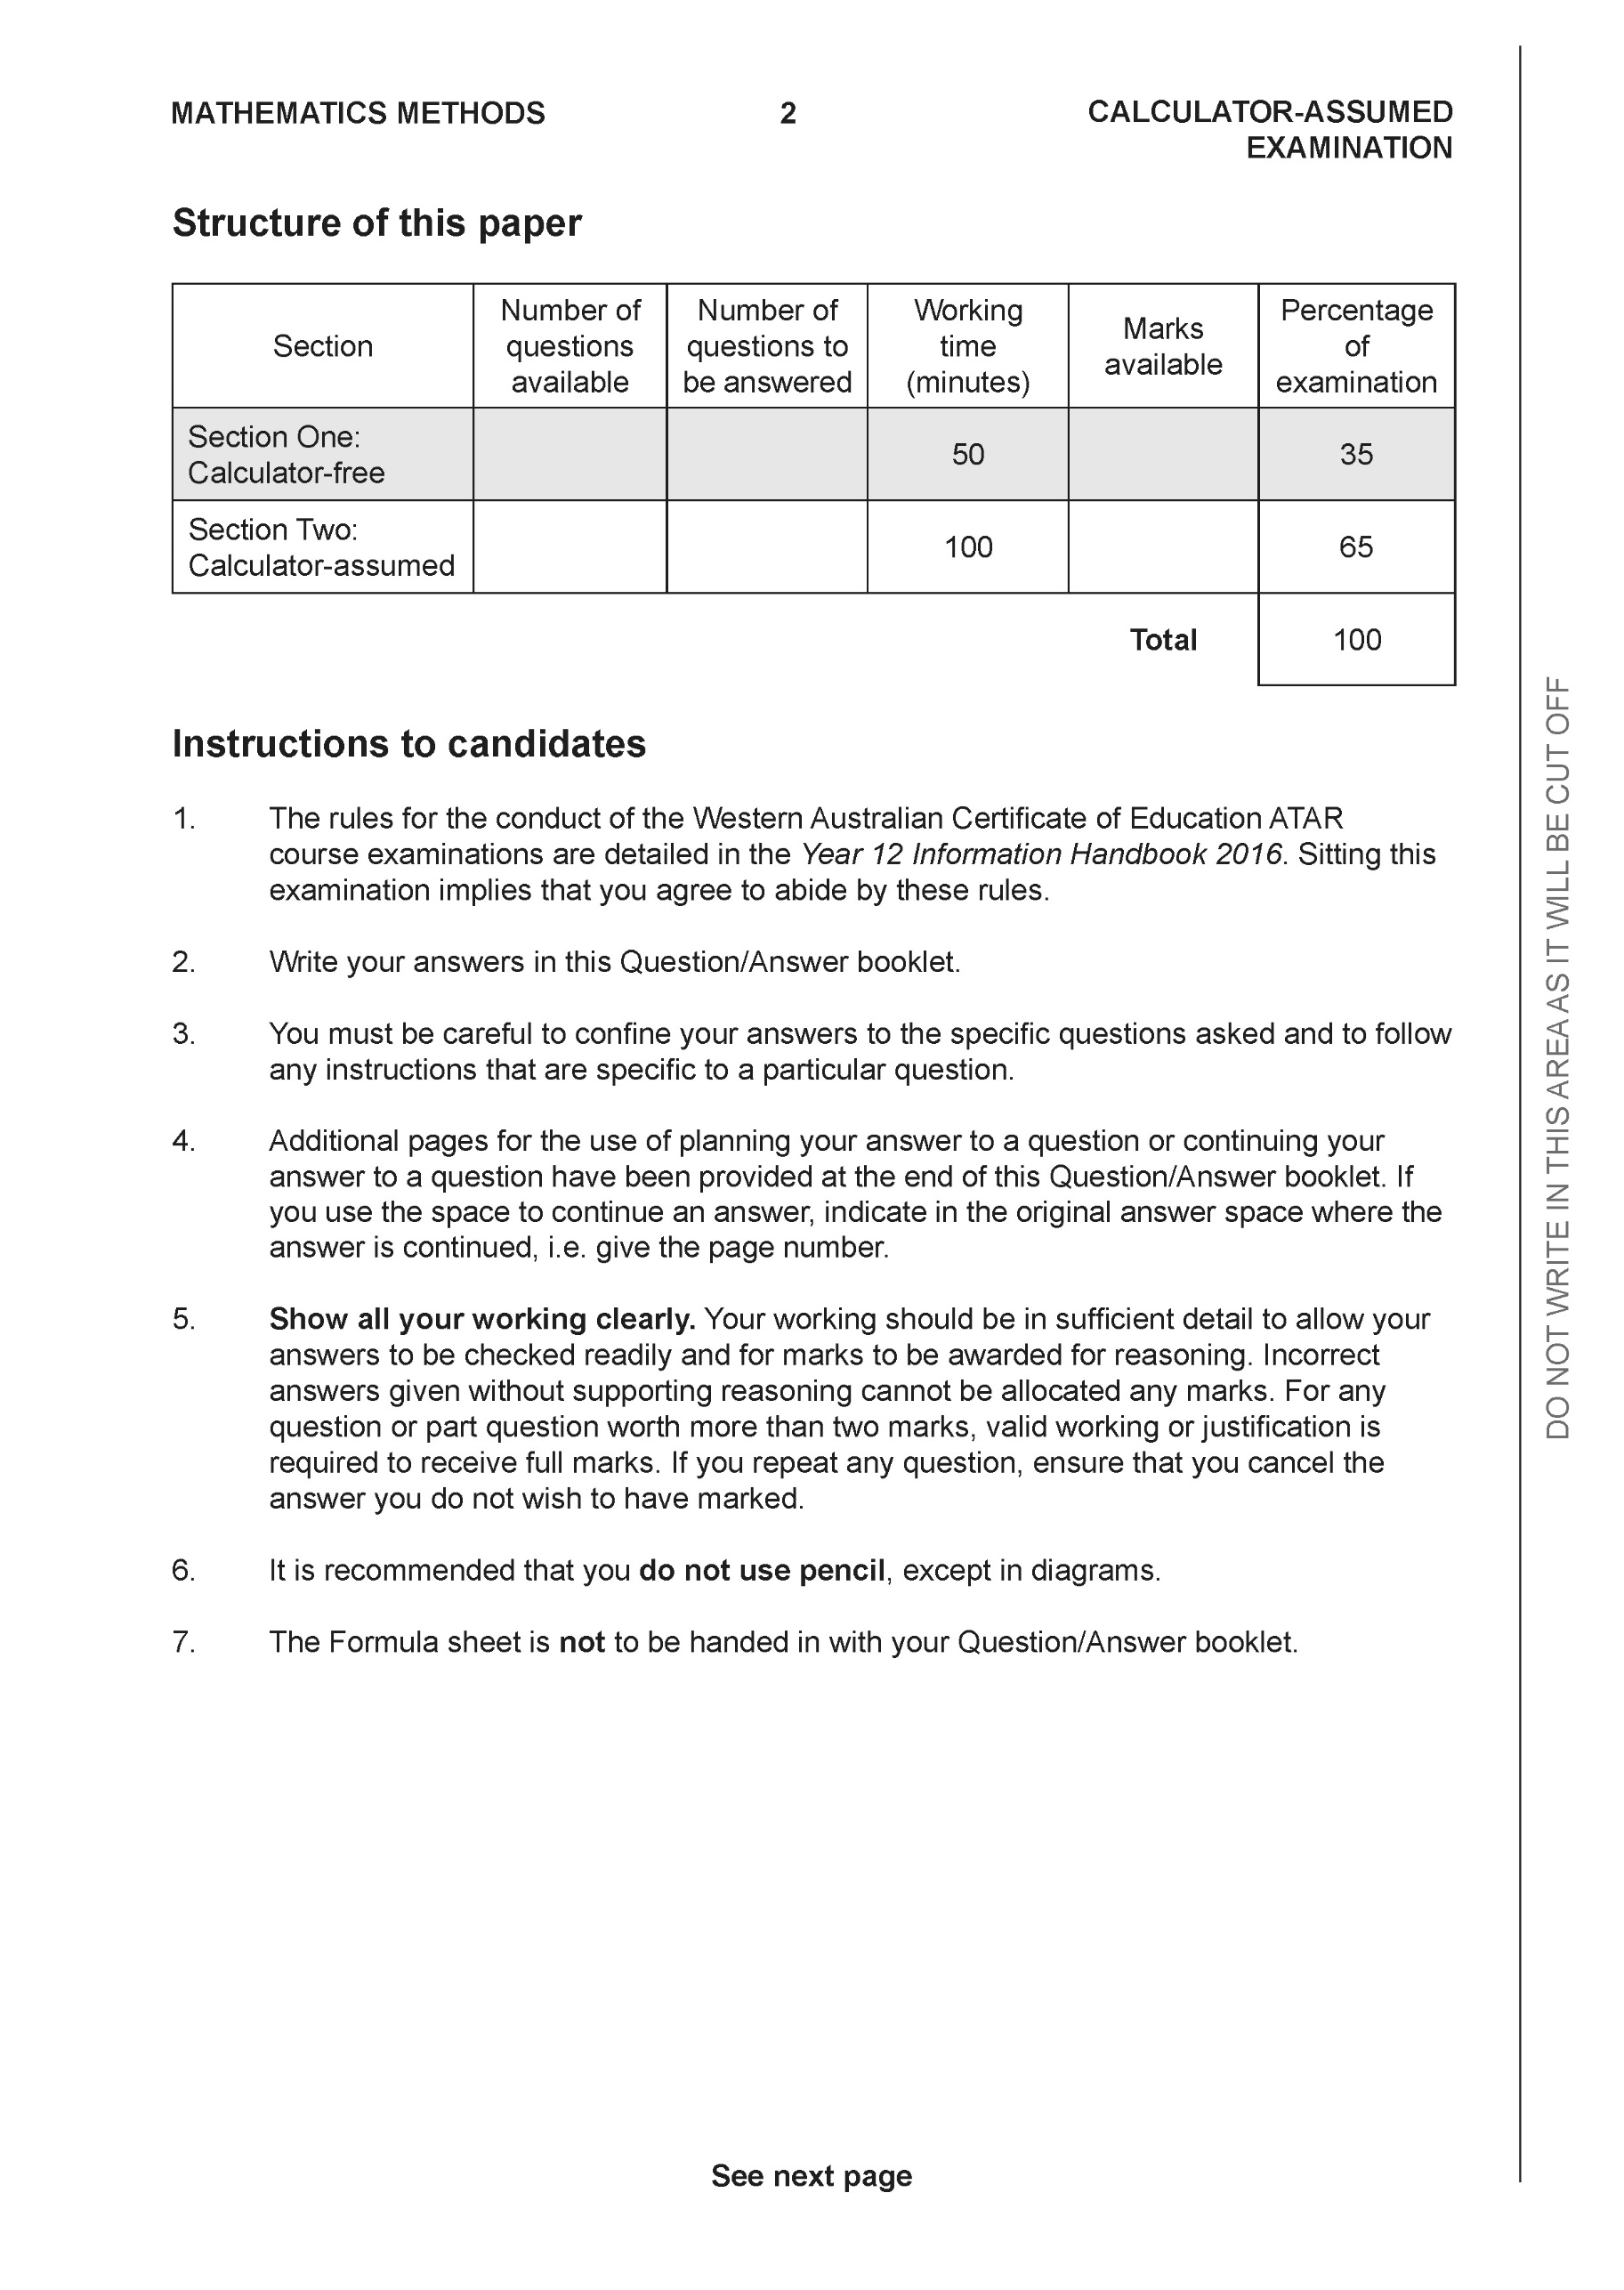

**Section Two: Calculator-assumed (97 Marks)**

This section has **13** questions. Answer **all** questions. Write your answers in the spaces provided.

Spare pages are included at the end of this booklet. They can be used for planning your responses and/or as additional space if required to continue an answer.

● Planning: If you use the spare pages for planning, indicate this clearly at the top of the page.

● Continuing an answer: If you need to use the space to continue an answer, indicate in the original answer space where the answer is continued, i.e. give the page number. Fill in the number of the question that you are continuing to answer at the top of the page.

Working time: 100 minutes.

**Question 7 (4 marks)**

Consider a ladder placed with one end, point A, on a wall and the other, point B, on the floor as shown below. The ladder has a length of 5 metres and point B is moving towards the wall at a speed of 3 metres per minute. When point B is 4 metres from the base of the wall, determine the speed of point A which is moving up the wall.

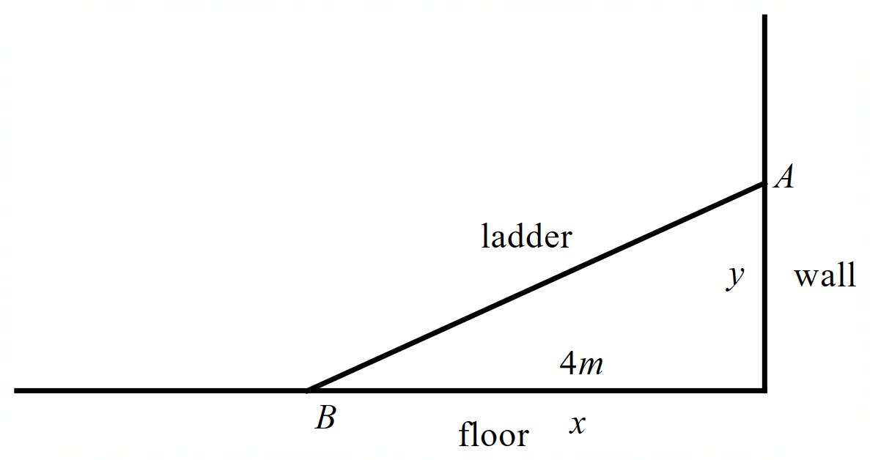

|  |
| --- |
| **c** |
|  |
| **Specific behaviours** |
| 🗸 introduces two variables  🗸 states equation linking both variables  🗸 uses implicit diff and subs known quantities  🗸 states required rate with units |

**Question 8 (10 marks)**

1. Consider the locus  in the complex plane.

Determine the following:

1. Minimum Arg(z). (3 marks)

|  |
| --- |
| **c** |
|  |
| **Specific behaviours** |
| 🗸 determines argument of centre of circle  🗸 uses tangent and acute angle of right angled triangle  🗸 states min argument in radians or degrees in fourth quadrant |

1. Maximum . (2 marks)

|  |
| --- |
| **c** |
|  |
| **Specific behaviours** |
| 🗸 determines modulus of centre  🗸 adds radius |

1. Sketch the following locus  on the axes below. The Arguments in this locus lie between the following . Determine the values of .

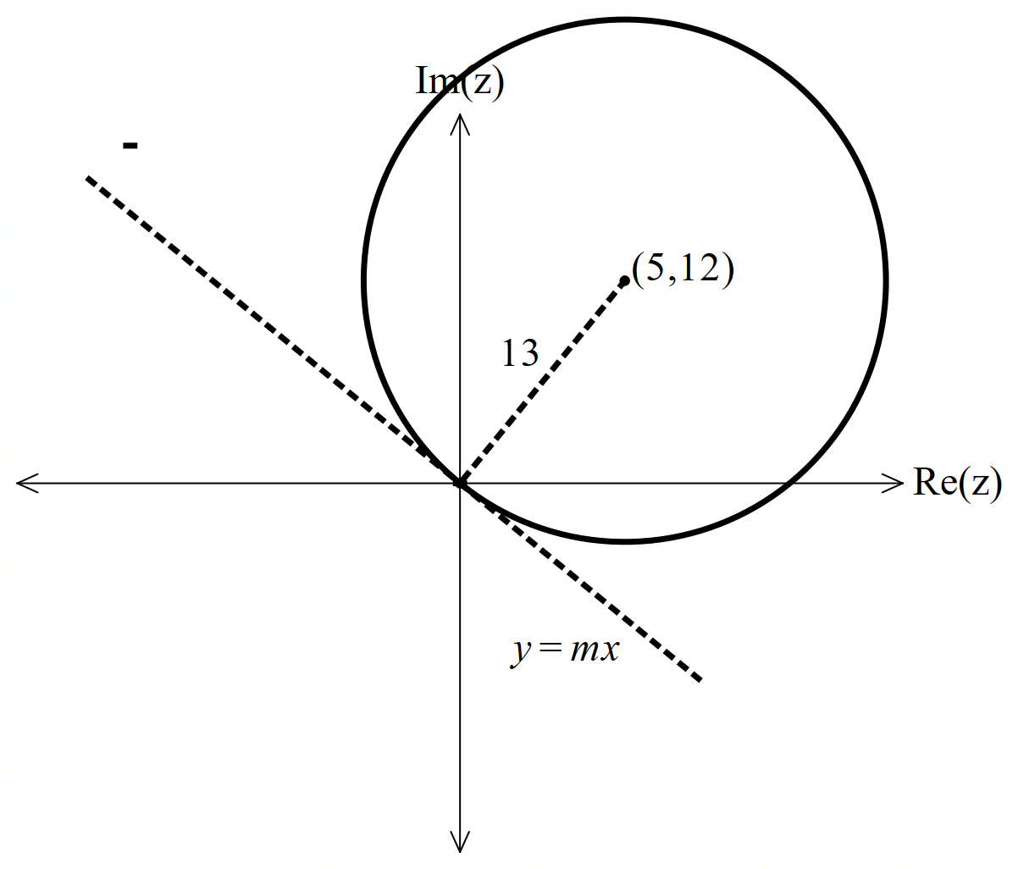 (5 marks)



|  |
| --- |
| **c** |
| b=-22.6 degrees (-0.395 rads)  c= 157.4 degrees (2.75 rads) |
| **Specific behaviours** |
| 🗸 sketches circle going through origin  🗸 determines gradient of radius line  🗸 determines gradient of tangent through origin  🗸 states lower argument (non inclusive)  🗸 states upper argument (non inclusive) |

**Question 9 (11 marks)**

Consider a racing car that travels in a racecourse with velocity  at time  hours. The initial position is . (See diagram below).

1. Determine the acceleration at  hours. (2 marks)

|  |
| --- |
| **c** |
|  |
| **Specific behaviours** |
| 🗸 diff velocity  🗸 subs t value |

1. Determine . (3 marks)

|  |
| --- |
| **c** |
|  |
| **Specific behaviours** |
| 🗸 integrates  🗸 subs limits  🗸 states position with units |

1. Determine the length of one track of the racecourse. (3 marks)

|  |
| --- |
| **c** |
| Length = 15.5 km |
| **Specific behaviours** |
| 🗸 determines period of one cycle  🗸 sets up integral  🗸 states distance with units |

1. Determine the cartesian equation of the path of the race car. (3 marks)

|  |
| --- |
| **c** |
|  |
| **Specific behaviours** |
| 🗸 uses double angle formula for sine  🗸 uses Pythagorean identity  🗸 states at least one possible cartesian equation |

**Question 10 (5 marks)**

Consider a particle that undergoes motion defined by  with ,metres being the displacement at time,  seconds. The velocity is zero when  metres.

Determine the percentage of time that the particle has a speed less than half of its maximum speed.

|  |
| --- |
| **c** |
|  |
| **Specific behaviours** |
| 🗸 recognizes that n=4 and A=9  🗸 states an expression for velocity as function of time  🗸 solves for times less than half of max speed in one cycle(Half cycle)  🗸 divides by length of cycle(half cycle)  🗸 states a percentage |

**Question 11 (5 marks)**

(a) Determine the solutions to in polar form and plot them on the Argand plane below. Label the solutions , , , , and in an **anti-clockwise** direction, starting from which is on the positive real axis. (3 marks)

**<EFOFEX>

id:fxd{4a597148-0010-42e6-ad05-f7fb6339c2d6}


FXData:


</EFOFEX>**

|  |  |
| --- | --- |
| **Solution** | **Specific behaviours** |
|  | * Determines at least half of the solutions correctly in polar form. * Determines all solutions in polar form. * Plots and labels all solutions. |

(b) There is a cubic polynomial with real coefficients whose roots are , and .  
Write down this cubic polynomial in the form . (2 marks)

|  |  |
| --- | --- |
| **Solution** | **Specific behaviours** |
|  | * Writes polynomial in factorised form (using rectangular or polar form of and ). * Writes down cubic polynomial. |

**Question 12 (13 marks)**

Given the points , , and .

(a) Determine the vector equation of the line through the points and . (1 mark)

|  |  |
| --- | --- |
| **Solution** | **Specific behaviours** |
|  | * Determines vector equation of the line. |

The vector equation of the line through and is .

(b) Determine the Cartesian equation of the plane, , containing the lines passing  
through and . (2 marks)

|  |  |
| --- | --- |
| **Solution** | **Specific behaviours** |
|  | * Recognises cross product of direction vectors gives the normal to the plane. * Determines Cartesian equation of plane. |

(c) (i) Show that , , and are coplanar. (2 marks)

|  |  |
| --- | --- |
| **Solution** | **Specific behaviours** |
|  | * Substitutes into plane * Explains why , , and are coplanar. |

(ii) Prove that is a rectangle. (2 marks)

|  |  |
| --- | --- |
| **Solution** | **Specific behaviours** |
|  | * Determines at least one additional side of the rectangle. * Shows that two sides are perpendicular and proves that is a rectangle. |

A sphere is constructed with its centre on plane from part (b).

(d) Determine the vector equation of this sphere if , , and lie on the surface. (3 marks)

|  |  |  |
| --- | --- | --- |
| **Solution** | **Specific behaviours** | **Point** |
|  | * Determines coordinates of centre of sphere. * Determines radius. * States vector equation of sphere. | 3.3.3 |

A set of three planes is given as follows:

(e) Determine the value of such that the above planes only intersect at the  
centre of the sphere found in part (d). (3 marks)

|  |  |
| --- | --- |
| **Solution** | **Specific behaviours** |
|  | * Substitutes in and forms a quadratic equation. * Solves for . * Rejects with reason, and states final value of . |

**Question 13 (6 marks)**

(a) By using partial fractions, show that:

(2 marks)

|  |  |
| --- | --- |
| **Solution** | **Specific behaviours** |
|  | * Correctly forms partial fractions. * Determines constants, and integrates to give result. Must contain absolute values. |

**<EFOFEX>

id:fxd{47d9f0dd-dd09-4a8a-9724-9f44c1a37b3e}


FXData:

</EFOFEX>**

On a coordinate plane, a point moves along a path, such that after

seconds , the position of the point is defined by

The direction of motion is shown in the diagram on the right.

(b) Determine when the angle between the direction of motion and the positive direction  
 of the -axis is . (4 marks)

|  |  |
| --- | --- |
| **Solution** | **Specific behaviours** |
|  | * Uses related rates to determine . * Determines * Determines at least one time when angle between the direction of motion and -axis is . * Determines second time. |

**Question 14 (6 marks)**

(a) By letting and , prove . (1 mark)

|  |  |
| --- | --- |
| **Solution** | **Specific behaviours** |
|  | * Correctly proves result. |

(b) By letting , use De Moivre’s theorem to prove that . (1 mark)

|  |  |
| --- | --- |
| **Solution** | **Specific behaviours** |
|  | * Correct proves result using De Moivre’s theorem. |

(c) A polynomial is divided by , where is a  
 complex number, leaving a remainder of .

(i) Using parts (a) and (b), show that the remainder when is divided  
 by is . (3 marks)

|  |  |
| --- | --- |
| **Solution** | **Specific behaviours** |
|  | * Correctly uses remainder theorem. * Substitutes in and uses part (b). * Uses part (a), and shows how to obtain required result. |

(ii) If for all solutions of it is known that , where is a complex

number what can be said about the coefficients of ? (1 mark)

|  |  |
| --- | --- |
| **Solution** | **Specific behaviours** |
|  | * States coefficients are real. |

Question 15

<EFOFEX>
id:fxd{1826068b-ee0a-4c05-af88-7ba9feaa7c37}

FXData:

</EFOFEX> (7 marks)

The slope field for the differential equation

where is a constant, is shown at right.

(a) Use a feature of the slope field to explain why and hence determine the slope at the point . (2 marks)

|  |
| --- |
| Solution |
| When and it can be seen that and so .  Slope at is . |
| Specific behaviours |
| ✓ explains using at  ü correct slope at |

(b) Determine the solution of the differential equation that contains the point in the form . (4 marks)

|  |
| --- |
| Solution |
| At , and so require |
| Specific behaviours |
| ✓ separates variables and antidifferentiates  ü recognises that to replace  ü evaluates constant  ü correctly expresses as a function of |

(c) Sketch the solution curve that contains the point on the slope field. (1 mark)

<EFOFEX>
id:fxd{1826068b-ee0a-4c05-af88-7ba9feaa7c37}

FXData:

</EFOFEX>

|  |
| --- |
| Solution (c) |
| See graph |
| Specific behaviours |
| ✓ ‘normal’ curve thru’ |

**Question 16 (7 marks)**

(a) Use the substitution to show that ,  
where is a constant of integration. (4 marks)

|  |
| --- |
| Solution |
|  |
| Specific behaviours |
| ✓ obtains and in terms of and  ü obtains simplified integral in terms of  ü obtains correct antiderivative  ü shows step(s) that clearly lead to required result |

<EFOFEX>
id:fxd{c0a07404-534d-4fd4-afde-f5518418e4e2}

FXData:
</EFOFEX>(b) The equation of the curve shown is  
  
.

Determine the area enclosed by the  
curve and the line . (3 marks)

|  |
| --- |
| Solution |
| Lines intersect when . |
| Specific behaviours |
| ✓ obtains bounds of integral  ü writes correct integral for area  ü correct area |

Question 17 (6 marks)

Consider the function , where and are positive constants.

The graph of cuts the -axis at , has a horizontal asymptote with equation and has a vertical asymptote with equation .

(a) Determine . (3 marks)

|  |
| --- |
| Solution |
| Horizontal asymptote .  Vertical asymptote |
| Specific behaviours |
| ✓ obtains value of one constant  ü obtains value of second constant  ü correct value of |

(b) Now consider the graph of . State the

(i) equation of its horizontal asymptote. (1 mark)

|  |
| --- |
| Solution |
|  |
| Specific behaviours |
| ✓ correct equation |

(ii) -axis intercepts. (1 mark)

|  |
| --- |
| Solution |
| Vertical asymptotes roots: . |
| Specific behaviours |
| ✓ correct intercepts |

(iii) equations of its vertical asymptotes. (1 mark)

|  |
| --- |
| Solution |
| Roots vertical asymptotes: and . |
| Specific behaviours |
| ✓ correct equations |

Question 18 (8 marks)

A machine fills bags with sugar. The mean and standard deviation of the weight of sugar it delivers into a bag is and grams respectively. An inspector routinely takes a random sample of bags filled by the machine.

(a) For repeated random sampling of bags of sugar filled by this machine, state the approximate distribution of the sample mean that the inspector should expect. (3 marks)

|  |
| --- |
| Solution |
| Let be the sample mean. Since the sample size is large then the distribution of will be approximately normal with mean g.  The standard deviation of is grams (variance)  Hence . |
| Specific behaviours |
| ✓ states that sample mean will be normally distributed  ü states the mean of the distribution  ü states the variance or standard deviation of the distribution |

(b) Determine the probability that the mean weight of a random sample of bags of sugar is at least grams, given that the sample mean is less than grams. (2 marks)

|  |
| --- |
| Solution |
|  |
| Specific behaviours |
| ✓ forms correct probability statement  ü correct probability |

(c) Occasionally, the inspector only has enough time to take a random sample of bags. In the long run, of sample means derived from samples with this smaller size will lie in the range grams. Determine the value of . (3 marks)

|  |
| --- |
| Solution |
| The new standard deviation of is grams (variance). |
| Specific behaviours |
| ✓ states new parameters of distribution of sample mean  ü writes correct probability statement  ü correct value of |

Question 19 (9 marks)

(a) Plot the complex number that satisfies the conditions and on the Argand diagram below. (2 marks)

<EFOFEX>
id:fxd{24f65691-ef6a-46f2-bd66-b90c0897e2a9}

FXData:

</EFOFEX>

|  |
| --- |
| Solution |
| See diagram |
| Specific behaviours |
| ✓ correctly indicates at least one ray  ü correctly plots complex number |

(b) Let and be another complex number. The locus of a complex number satisfies the condition and is shown in the diagram below.

(i) Determine the complex number . (2 marks)

|  |
| --- |
| Solution |
|  |
| Specific behaviours |
| ✓ indicates point lies on perpendicular to locus through  ü correct complex number |

(ii) On the same diagram, indicate the locus of a complex number that satisfies the condition . (1 mark)

<EFOFEX>
id:fxd{a9e877f4-07d4-44ce-9f16-ef33c6c53768}

FXData:

</EFOFEX>

|  |
| --- |
| Solution (b)(ii) |
| See shading on diagram |
| Specific behaviours |
| ✓ correct shading |

(c) The locus of points that satisfy is an arc of a circle.

(i) Sketch the locus of in the complex plane. (2 marks)

<EFOFEX>
id:fxd{c32d4d29-1ad9-4f9c-8582-8bbb8c24334b}

FXData:

</EFOFEX>

|  |
| --- |
| Solution |
| Anticlockwise major arc from to .  *NB Marks for location of major arc rather than neatness/curvature* |
| Specific behaviours |
| ✓ major arc of a circle drawn anywhere  ü correctly locates endpoints and major arc drawn to their right |

(ii) Determine, with justification, the exact location of the centre of the circle. (2 marks)

|  |
| --- |
| Solution |
| When , then and a right-triangle is formed in the circle. The midpoint of the hypotenuse of this triangle must be the centre of the circle. Hence the centre is at |
| Specific behaviours |
| ✓ indicates adoption of suitable method  ü correct centre, fully justified |

Additional working space

Question number:

Additional working space

Question number: